Batch processing is execution of a series of programs ("jobs") on a computer without manual intervention. This is in contrast to "online" or interactive programs which prompt the user for such input. It avoids idling the computing resources with minute-by-minute as compared to manual intervention and supervision.
EX: Salary processing for organization, payment for a multiple vendor by organization.

Spring Batch is an open source framework for batch processing. It is a lightweight, comprehensive solution designed to enable the development of robust batch applications vital for the daily operations of enterprise systems. It can be used in
- processing large volumes of records, including logging / tracing, transaction management,
- job processing statistics,
- Job restart, skip, and resource management.
- It also provides optimization and partitioning techniques to run batch jobs

Spring batch is not a scheduler. It doesn’t provide advanced support to launch them according to a schedule. It overlaps with scheduler such that spring batch can sequence the job step similar to scheduler, but within limit of jobs.

Should a whole batch fail because of single step failing? Not always. The decision what to do on failed step is declarative in Spring Batch. It’s all about configuration.

What happens if you restart a failed batch job? Should it start from the beginning—
potentially processing items again and corrupting data—or should it be able to
restart exactly where it left off? Spring Batch makes the latter easy: components can
track everything they do, and the framework provides them with the execution data
on restart. The components then know where they left off and can restart processing
at the right place.

commitInterval – periodical level of transaction commit.
Item Oriented Processing : Older Approach Prior to spring 2.0
Interface ItemReader{
Mark() - mark the beginning of reading item.
Read() - actual read.
Reset() – if writer fails, reset called, which go back to marked read item.
}
Interface itemWriter {
Write() – actual write
Flush() – if write success
Clear() – if write fails, calls reset of itemreader
}

for(int i = 0; i < commitInterval; i++){
Object item = itemReader.read();
itemWriter.write(item);
}

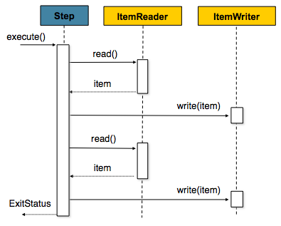

Chunk oriented processing : Spring Approach 2.0

public interface ItemReader<T> {

T read() throws Exception, UnexpectedInputException, ParseException;

}
public interface ItemWriter<T> {

void write(List<? extends T> items) throws Exception;

}

List items = new Arraylist();
for(int i = 0; i < commitInterval; i++){
items.add(itemReader.read());
}
itemWriter.write(items);
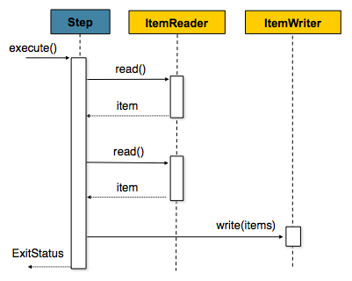

Chunk Processing can be single threaded or multithreaded.
MultiThreaded Chunk Processing happens by Partitioning.
Partitioning splits steps into substeps each of handles specific portion of data.

ItemProcessor is optional. It is needed only if transformation of data is required.
Spring Batch also has validation and filter. EX: if validation fails or processing fails writing can be skipped.

Job – Step – Tasklet - Chunk

Chunk Size and Commit Interval are same.
If Chunk size small, too many transactions open. Job runs slow
If Chunk size is big, job is fast, db roll back will takes time

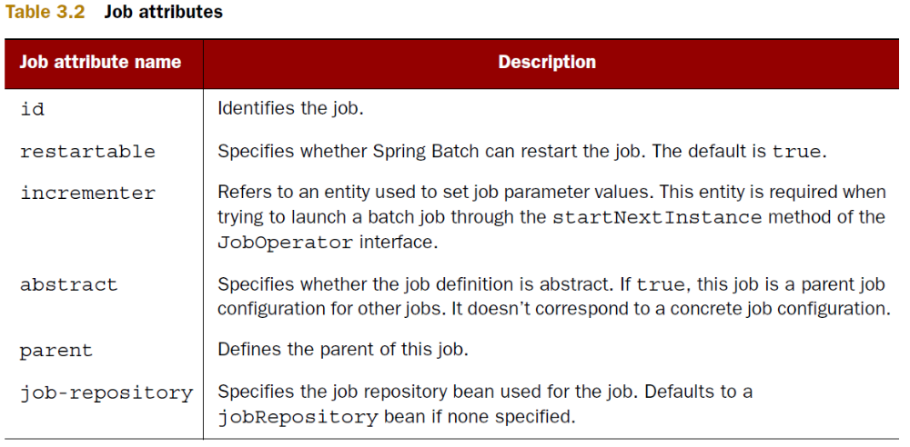
Besides these attributes, the job element supports nested elements to configure listeners
and validators.

<batch:job id="importProductsJob" incrementer="customIncrementer">
(...)
</batch:job>
<bean id="customIncrementer" class="com.manning.sbia
➥ .configuration.job.CustomIncrementer"/>

<batch:job id="importProductsJob">
(...)
<batch:validator ref="validator"/>
</batch:job>
<bean id="validator" class="org.springframework.batch
➥ .core.job.DefaultJobParametersValidator">
<property name="requiredKeys">
<set>
<value>date</value>
</set>
</property>
<property name="optionalKeys">
<set>
<value>productId</value>
</set>
</property>
</bean>
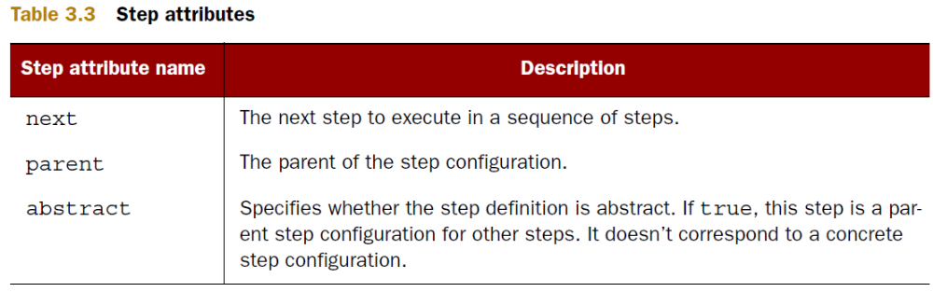

A tasklet corresponds to a transactional, potentially repeatable process occurring in a
step.

Spring Batch has two infrastructure components:
■ Job repository—To store the state of jobs (finished or currently running)
■ Job launcher—To create the state of a job before launching it

Job – step – tasklet – chunk

Joblauncher – jobRepository – transactionManager – datasource

Best Practice
Configure infrastructure and Application Configuraton in separate xml file.

Step1
1) DecompressTasklet Java file
Step2
2) ProductFieldSetMapper
3) Reader xml file
4) Writer Java file
5) Writer Xml file
Combine Step1 and Step2
6) Job xml – commit interval is set at chunk. if commit is 10, for 10 read 1 write.
Infrastructure Configuration
7) Launcher XML
Test Class

